5. Use Cases

**5.1 Employee Maintenance System:**

Overview

This project is aimed at developing Online Employee Maintenance System. This is an Intranet based application that can be accessed throughout the organization and this is a web based application that can be accessed over the web. This system can be used to search for Employees based on search condition, add individual employee, modify an existing employee details and display all employee details across locations within an organization. Employees can apply for leave and the leave record will be updated and can be approved or rejected by manager. This is an integrated system that contains both the user (Employee) component and the Admin component.

Prerequisite

User must be logged in as Admin to perform the add , update and delete an employee functionalities.

User must be logged in as Manager to perform Approve/reject Leave, Reason for rejecting leave, view subordinate details functionalities.

User must be logged in as Employee to perform Apply leave, check status of leave functionalities.

Functionalities like searching an employee and login can be performed by any of the user.

Non Functional Requirement:

All modules are show designed that the result will be obtained within 10 seconds of request. Proper Loading indicator has been instantiated. Hence once a request been asked no one can further request anything. Authentication has been given a higher priority. All form validations are properly maintained

Use Case Diagram for Employee Maintenance System

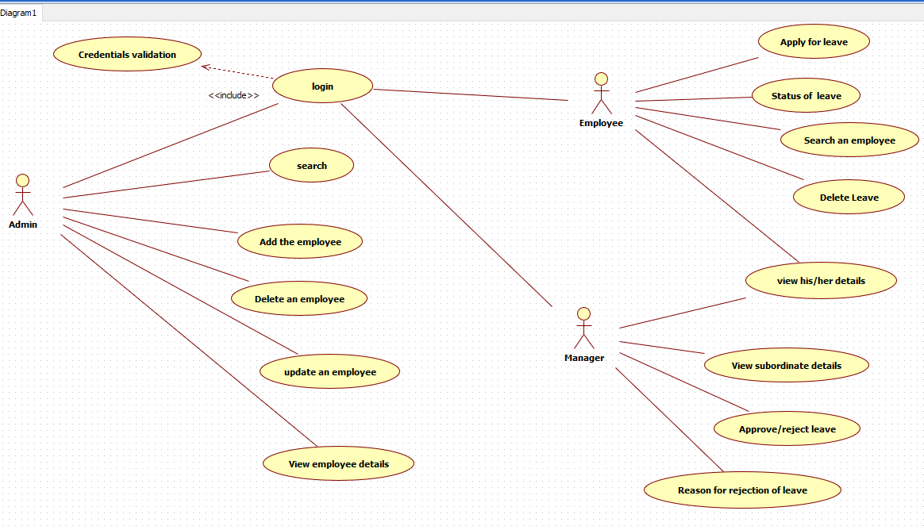

Class Diagram for Employee Maintenance System

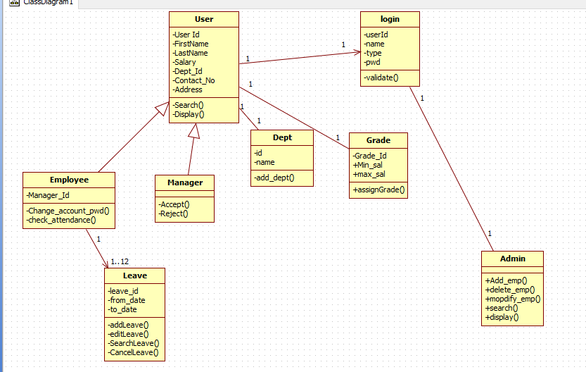

a)  Add an Employee

This module has been designed to add a Employee in the database. This can be only accessed by Admin. The form is designed with proper validation.

Validation:

Employee Id: Employee id should be unique.

All fields are required.

b)  Delete an Employee

This module is designed to delete an Employee from the database. This can be only accessed by Admin. An employee may leave the organization and join in another organization. After the employee left the organization his/her data has to be removed from the database. To perform this task we made this module.

c)  Update an Employee

This module is designed to update an Employee in the database. This can be only accessed by Admin. There might be a possibility that employee details are entered wrong or employee data may require some modifications. For example Employee recently took a new sim card and that data must be updated in the database. To perform this task we made this module. Using this module admin can update the details of the employee.

d)  Search an Employee

This module is designed to search for an employee. This can be performed by any of the user. In this module we provided a search functionality by applying some filters. For example if an employee want to know how many are working in his location he can get that information by applying a filter on location. There are other filters on designation and salary also. This module is just a read only module user can just read the information, user cannot do any modifications in the database by using this module.

 e) Apply a Leave

This module is designed for employee to apply a leave. This can be only accessed by Employee. If employee wants to apply a leave for some reason, for example employee may fall sick, employee may want to go for a vacation etc. In this case employee must apply for a leave. This module provides the functionality to apply a leave. Before applying a leave it checks in the database whether the employee is having leaves or not . If employee has leave it allows the employee to apply a leave. If employee is not having any leaves error message will be displayed.

 e) Approve a Leave

This module is designed for approving employee’s leave. This can be only accessed by Manager. Employee can go on leave only after it is approved by manager. Manager can access this module for approving employee’s leave.

  e) Rejecting Leave with Reason

This module is designed for rejecting employee’s leave. This can be only accessed by Manager. It is not necessary that manager always approves employee’s leave, in some cases he may reject employee’s leave. For example if the project deadline is near and his presence is important for completing the project on time he may not approve his leave. In this case manager uses this module for rejecting employee’s leave, manager must provide a reason for rejecting employee’s leave.

  f) Checking Status of Leave.

This module is designed for employee for checking his leave status. This can be only accessed by Employee. Employee can use this module for checking his leave status. After employee applies for a leave it has to be approved by manager before going on leave. Manager may cancel his leave. This modules provides the functionality of checking the status of leave this have 3 cases.

1. Leave status is pending (Manager neither rejects nor approves).
2. Leave status is approved (When manager approves the leave).
3. Leave status is rejected (When manager rejects the leave).

  g) Cancel a Leave

This module is designed for employee for cancelling his leave. This can be only accessed by Employee. Employee can cancel his leave before 3 days from applying. Employee can not cancel his leave after three days or once manager approves his leave. There can be a case where employee decides to cancel his leave after applying. For example employee decides to go for a vacation and applied a leave, suddenly vacation got cancelled due to non-availability of tickets, in this case he has to cancel his leave. This module provides the functionality to cancel a leave based on above mentioned conditions.

h) View Subordinate details

This module is designed for manage to check all the details of employees under him. This can be only accessed by Manager. There might be a case when manager want to check his subordinate details. For example if manager wants to check attendance of all the employees under him, he can use this module to check all the employee details.

Sequence diagrams